**Chrome browser installation**

**Version 1.0**

**Version History**

|  |  |  |  |
| --- | --- | --- | --- |
| **Version** | **Date** | **Handled by** | **Comments** |
| V1.0 | 17-May-2019 | ZL Chen | First version release. |
|  |  |  |  |

Precondition Setting:

Please make sure the DUT is connected to the internet.

Please follow the installation steps as below:

Step 1:

Please find the “ChromeSetup.exe” under the installer folder, and then double click this one.

Location: .\automation\installer

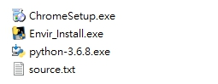

Step 2:

Make sure the installation is completed.

